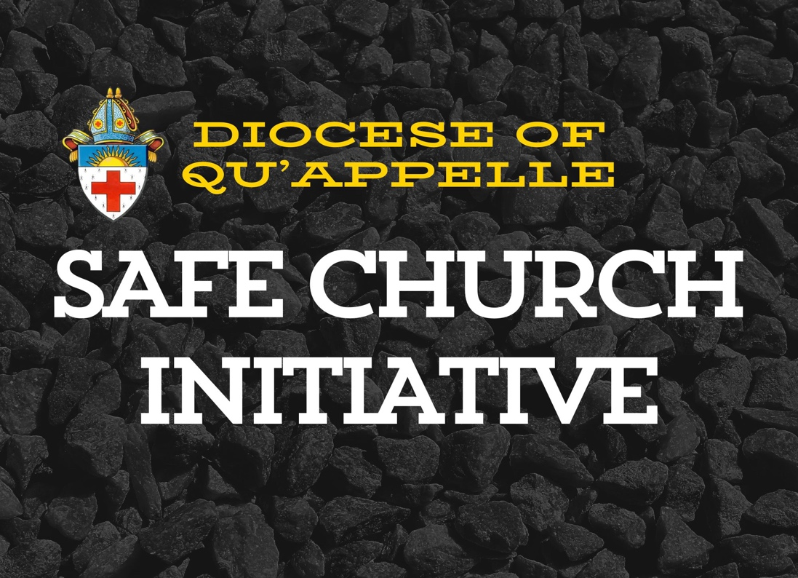

Table of contents

History 2
Safe Church Policy 3
Safe Church Guidelines
Caring for Property 5
Caring for People 9

History
The Safe Church initiative began as result of a recognition by both the Anglican Church of Canada and the Ecclesiastical province of Rupert’s Land that we have a biblical and legal obligation to ensure that we are caring for our property and people as best we can.

The General Synod of the Anglican Church of Canada passed Resolution A-128 which states that it shall:
1. “Adopt The Anglican Communion Charter for the Safety of People and the Protocol for the Disclosure of Ministry Suitability Information between the Churches of the Anglican Communion;
2. Commend the Charter to dioceses and other bodies of The Anglican Church of Canada for use in the revision and creation of policies and training materials for safeguarding and right conduct…”
Source: https://www.anglican.ca/faith/ministry/safe-church/

The Anglican Communion Safe Church Charter Commitment 5: A Culture of Safety states “we will promote a culture of safety in parishes and church organizations by education and training to help clergy, other church personnel and participants prevent the occurrence of abuse.”
Source: Implementing the Anglican Communion Safe Church Charter In the Anglican Church of Canada: A Guide for Review of Policy and Practice

In response to this, the Province of Rupert’s Land, now knows as the Province of the Northern Lights, produced a resource designed to assist each parish to take “protective action” to strengthen administration and stewardship of our property, both real and financial, as well as care for the members of the Body of Christ.
Leaders in our Diocese have a moral, fiduciary and scriptural obligation to
“care for, support, and protect the most vulnerable in our world….the best way to protect the vulnerable and to safeguard ourselves is to provide competent and effective administration at all levels of the Church.”
Source: Ashdown, Rt. Rev. David, Ensuring Sustainability (Qu’Appelle Version), January, 2018, p. 9.

In June of 2018, our Diocesan Council passed a motion approving this resource, entitled Ensuring Sustainability: A "Best Practices" Risk Management Package for Parishes for use diocesan-wide. A copy is on the Diocesan website.

Since that time, we have discerned a need for a new type of Safe Church assessment and resource tool that better responds to the needs of parishes.

Safe Church Policy
Parishes are required to answer the following questions on the annual parochial return form. If they answer no, the Safe Church officer will follow up and provide guidance and support.
In the last year, has your leadership:
  - Shown the Diocesan Safe Church video to new Vestry members?
  - Used the Discussion Guide to talk about the Safe Church initiative in your parish?
  - Reviewed your policies and practices around:
    - Caring for property (building maintenance and safety, records, and rental groups)?
    - Caring for people (emergency response, volunteers, staff, pastoral care, and children)?
This policy is accompanied by an information video and discussion guide to help you in your commitment to caring for people and property.
If the answer to any of the above questions is no, please make a commitment to do so this coming year. If you need help, please contact your Safe Church officer, Kate Berringer at kate.berringer@quappelle.anglican.ca.

Safe Church Guidelines
Whatever you do, do it enthusiastically, as something done for the Lord and not for men, knowing that you will receive the reward of an inheritance from the Lord. You serve the Lord Christ. – Colossians 3:23-24
Caring for Property
Real Property
Real property consists of buildings and rectories owned by the Diocese that are in the care of the parish. Basic care of these facilities is all about doing our best to avoid theft, vandalism or damage to the building contents, as well as to the buildings themselves. It also means keeping those who use the building safe.

How does property insurance fit in to this? We pay insurance premiums to ensure that we have financial resources to access if an incident occurs that leads to loss or damage of property. Insurance coverage can be denied if the insured (us) have not done what can be reasonably expected of them to mitigate or prevent a loss from occurring. For example, an insurance company may not pay a claim for loss of items in a building through theft, if the building was deliberately left unlocked. They may not pay a claim for damage to items in the building if it is rented to an outside party and there is no agreement in place to ensure that the renter takes responsibility for damage to the property while they are using it. Ensuring that doors are kept locked when no one is in a building and requiring an outside party to sign an agreement to take responsibility for damage that they may cause, are examples of practices that show our care for property.

This is part of our stewardship role. Doing what we can to prevent items being stolen or damaged or prevent our buildings from being vandalized, flooded or burned down means that if it does happen, we are able access money to repair or replacement through an insurance claim. Doing our best to ensure that loss will be covered and that we can recover money to replace or demolish property is caring for the resources we have been given.

Caring for our buildings also impacts our people. Caring for our property involves taking steps to avoid injury to the people who use them.

Snow removal

If people regularly use a sidewalk to enter your building, keeping it free of snow and ice may prevent a slip and fall incident. If someone is injured and wishes to access the financial resources available through liability insurance, the insurance company will often look at how often and how well the sidewalks are kept clear when deciding if insurance coverage will apply. Keeping a written record of when snow is removed is helpful, as not everyone can easily remember when or if tasks like this occurred, especially if it occurs sporadically.

Basic building maintenance

If there are areas in your church building where someone could fall or hurt themselves easily, care for people means that we ensure that those hazards are either fixed or are easily noticed so that people can avoid them. It is helpful to have a written record of these maintenance repairs and projects so that we can show that we did our best to avoid harm.

Our care of people means doing what we can to ensure that insurance money is available to the person who suffers a loss by way of a slip and fall, either on a slippery sidewalk or by tripping on a loose stair. Outside or inside, providing good lighting, hand rails and repairing or preventing uneven or lose flooring can prevent most falls.

It is also helpful to ensure that we comply with fire safety precautions so that people can safely avoid harm if a fire does occur when people are present in the building. This may also involve regular furnace/boiler and electrical inspections to ensure that fire hazards are avoided.

Sometimes, caring for property means being astute in our expenditure of money for another party to repair or upgrade a building or items in a building. It is also important when hiring an outside party to perform maintenance work that both the parish and the contractor have agreed on a price, the timeline and details of the project, and that the contractor has confirmed that they have insurance to cover injury to themself and their employees and possible damage to the parish building. This agreement can be verbal or in writing, however a written agreement of some kind can be useful if a dispute arises.

Access to parish buildings

When caring for our buildings, we want to ensure that we are preventing easy access. Often parish buildings are used by a variety of outside groups during the week. Should a theft or other incident occur, it can be helpful to know who was in or around the building when it happened. It can also be useful to know who was last in the building before an incident. There are steps that can be taken to ensure this information is readily available by having a sign in/sign out log for people entering or exiting the building, keeping an updated list of when people are regularly scheduled to be in a parish building, and ensuring that all who have keys or alarm codes understand their responsibility to ensure the premises are kept safe while they are there and when they leave. One way to achieve this is to ensure all key holders sign an agreement detailing what is expected of them.

Property in your parish buildings
Kitchen ministry - serving food

If food preparation and serving areas are not kept clean and well maintained, there is a risk of harming those who ingest the food that is served. Caring for people means ensuring that we take steps to ensure no one gets sick when they eat food that we serve. Cleaning and maintenance checklists are helpful tools that can be used to make sure all recommended precautions are being followed.

If your parish does a lot of food preparation, it may be helpful to have one or more parishioners complete a food safety course. Many are offered online. Visit www.quappelle.anglican.ca for approved courses.

Financial and other records

Caring for property means keeping proper meeting minutes so that decisions that are made are clearly detailed, especially around spending money and looking after or disposing of property. This is important when/if a decision is later questioned or needs to be revisited by parish members or the Diocese. Safe storage of these records for long as they may be needed is part of our care for property. Our Archivist, Trevor Powell, has produced an excellent resource about what types of records and for how long should be kept. It can be found on our website here: https://quappelle.anglican.ca/archives. Keeping records in the parish for longer than necessary can create problems for the Diocesan Archivist. Regularly forwarding relevant documents to the Synod office for storage, rather than waiting several years and then sending over a massive amount of material at once, allows the Archivist to better care for them.

Records such as membership lists, vestry books and wedding/funeral/baptism/confirmation registers are less important from a legalistic perspective but are vitally important if we consider them to be part of our story as a Diocese. Preserving the story of the people who have worshipped and received the Holy Spirit through the sacraments in our parishes is part of caring for our people.

Financial records are important because they show how money the parish uses its money to fund its activities. This is also a vital part of stewardship. The money parishes receive from its members, as well as outside donors and grantors, is first and foremost given them by God. It is then given to us as an expression of gratitude for His blessing. Everything that we have is His to use to His glory. Keeping records of spending, donations, and other income honours that which we are given.

Allowing donations and tithing by online banking requires a responsibility to take steps to keep that information safe. Frequently updating cybersecurity measures on your systems, ensuring that you have a backup copy of your records, and ensuring that all staff and volunteers who work with banking information are trained and understand safety best practices is all part of caring for property.

Keeping records to indicate that taxes are paid, money is spent in accordance with an approved budget, and that everyone who spends money on behalf of the parish is authorized to do so, means we are caring for property that has been entrusted to us.

If your records are kept electronically, caring for them means making sure they can still be accessed even when your parishes storage system fails. This usually means ensuring that they are backed up and a copy is stored offsite and can be accessed at any time.

The Diocesan Finance committee has prepared several resources to help parishes with their financial activities and ensure that records are properly kept. The parish finance manual is on our website. There are also several how-to videos on our website to help parishes with tasks such as filing the CRA return.

There are also plenty of resources and tips out there for non-profit organizations on how to best keep online information safe, including www.techsoup.ca.

Furniture and other items

Keeping track of items that are in our parish buildings means that if something is damaged or goes missing, we have proof of the existence of an item and can make a claim to our insurer to have the item replaced or repaired. This can be done by way of a photo catalogue or other type of list. Taking steps to ensure that property that is useful to our parish life will continue to be available as long as it is needed is caring for property.

Parish communication

Emails between parishioners, clergy, and others are a type of property. They can be accessed to determine how a conversation among two or more people occurred, what was said and when. Keeping emails that contain important conversations can be useful if there is a need to go back and look at what was said, should a dispute arise. Keeping emails that hold important conversations is care of property.

Conversations that happen by email can also include confidential information. Caring for people means not disclosing confidential information in an email, either intentionally or unintentionally. Taking steps to ensure that the contents of emails can only be seen by those who have authority is caring for people.

Rectories

It can be helpful to have an agreement in place between the parish and the incumbent who is living in a Rectory. The agreement can be similar to that of a landlord and a tenant. It often states who is responsible for the upkeep of the home, its contents and the grounds, and what steps the incumbent is expected to take to keep the premises safe from theft, fire, flooding and other incidents that may lead to a loss.
Ensuring that the rectory is well-maintained is caring for our property.

Caring for people

Do nothing out of selfish ambition or vain conceit. Rather, in humility value others above yourselves, not looking to your own interests but each of you to the interests of the others. Philippians 2:3-4

Safety procedures

You are responsible to ensure everyone is kept safe during an emergency. There may be professionals in your congregation (fire fighters, EMS staff) who can be identified and called upon to help in an emergency. It is helpful to have an emergency response plan which clearly outlines who is in charge and their responsibilities. Making sure that an incident is handled efficiently and calmly is showing care for people. A sample emergency response plan can be found on the Diocesan website.

Incident reports

When an incident occurs that either results or almost results in damage to property or injury to a person, it is helpful to have a record of what occurred, so that if questions arise as to the details, a record exists. It may seem inconvenient and unnecessarily time consuming to complete a report, but it can save a lot of time and effort later on if the incident leads to an insurance or other type of claim. Having blank forms easily available and encouraging those involved to fill them out when an incident occurs is helpful for guiding maintenance volunteers or staff to repair or rectify problems. The Diocese requires information about serious incidents that may lead to insurance liability claims or law suits. In those cases, having an incident report completed immediately and sent to the Diocese is vital.

Volunteers

Every generous act and every perfect gift is from above, coming down from the Father of lights; with Him there is no variation or shadow cast by turning. James 1:17

Volunteers are the life-blood of our parish ministries. Most of what happens in the parish context is because of volunteers. Caring for our volunteers means first and foremost showing appreciation for their willingness to give of their time and talents for His glory. Regularly expressing gratitude and thanks to the Lord for our volunteers is a great way to show care.

It is also helpful to ensure that a volunteer understands and is oriented to the task(s) they are undertaking and that they know what tasks both are and are not their responsibility. Knowing who to report to and seek guidance from is also important for a volunteer.

Caring for our volunteers also means setting aside time once a year to review their position and ask for and give feedback about how they are doing.

Employees

Caring for our employees means being very clear about the terms, remuneration and policies that affect their employment. Many disputes between employers and employees stem from disagreement as to the terms upon which a person was hired. Clearly laying out the job description and the employer’s responsibilities ensures that everyone knows what is expected. This provides a framework for conversations about performance and expectations. Hiring a person for a job without clearly outlining what is expected is not caring for the employee.

As with volunteers, caring for our employees means setting aside time once a year to review their position and ask for and give feedback about how they are doing.

Employee and Volunteer screening

We also have an obligation to ensure that an employee we hire or a volunteer that we recruit is suitable for the task she is hired to do. Requiring an employee or volunteer to provide a recent criminal record and/or vulnerable sector check shows that we care about the suitability of the people we ask to minister to our parish family.

Seniors and others requiring pastoral care

This resource addresses pastoral care generally, provided by both clergy and lay people. More specific pastoral care guidelines for clergy are available through the Synod office. Pastoral care often involves one on one meetings with someone who is bereaved, sick, or injured and can occur in a home, a hospital, or a care facility.

These relationship dynamics are different from that between a clergy or lay visitor and someone is not in a vulnerable position. People who are in crisis are often more susceptible to be victimized by inappropriate behaviour. As such, there is an power imbalance that must be kept in mind when the visitor makes decisions about how and where to meet.

When it can be arranged, it is helpful to ensure another person is nearby when visiting a person requiring pastoral care. This prevents situations where an allegation is laid and only the two parties involved are witnesses to the incident. Not only does having another person present or nearby prevent inappropriate conduct, it helps avoid even a perception that an incident may have occurred. Avoiding situations where a vulnerable person and a visitor are alone, is care for both the person being visited and the visitor themselves.

Caring for each other in this context is also achieved by ensuring both parties understand the intention of the visit, that the visitor keeps information obtained in the visit confidential, and that the visitor keeps a record of the time, place and nature of the visit. This ensures that everyone is clear about the parameters of the relationship.

It is helpful to have lay visitors complete training about the do’s and don’ts of visiting someone who is vulnerable, so as to avoid inadvertent behaviour that can lead to an allegation. It is also helpful to ensure that a lay visitor understands the limitations of their visitor role, when it comes to providing care. Some care support is only to be offered by an ordained person.

Caring for the vulnerable also means being aware of signs of abuse so that if it is suspected, the visitor is aware of the procedures he or she can take to report.

Children

Children under eighteen are considered to be unable to protect their own interests when it comes to inappropriate behaviour. Therefore, extra steps to ensure they are safe are very important. Caring for children means doing everything possible to prevent them coming to harm. This means ensuring parents or guardians give consent to activities and acknowledge the potential risks. It also means preventing children being left alone with an adult who is a non-family member. This avoids both the possibility of inappropriate behaviour as well as the perception of this type of behaviour. Keeping doors to activity areas open so adults can witness children’s programming at any time is helpful. Ensuring that an adult always takes two or more children to the washroom at one time, rather than a lone child also helps avoid inappropriate behaviour. Avoiding any situations where an adult and child are alone together behind a closed door is showing care for people.

Nowadays, the minimal standard for ensuring children are well cared for is to insist upon a criminal record/vulnerable sector check for all adults working with children. While this does not completely prevent incidents from occurring, it can be problematic when an organization is required to answer to a decision not to ask this of its volunteers or employees. It is a relatively easy way to show that the care of children is a priority.

Caring for children also means being aware of the signs of sexual, physical, or emotional abuse in a child so that if abuse is suspected, an adult has access to the procedures for reporting their concerns. The Diocese of Qu’Appelle has both a policy and procedures for suspected sexual misconduct as well as bullying and harassment. Caring for our people means ensuring both those who suspect abuse and those who have been victimized can access these policies and procedures easily, without having to disclose confidential information to a fellow parishioner or to clergy. This means ensuring that parishioners know about the Diocesan website and where to find these resources.

Where can we find resources to use to keep our people and property safe?

There are several resources provided on the Diocesan website under “Safe Church”. If a resource that you are seeking is not there, please contact the Diocesan Safe Church officer who will be able to help you out. If you are not sure, please ask!

